Hands-On Assignment 4: Fraud Detection Using PyOD AutoEncoder
Xhon Pelushi
University of the Cumberlands
MSCS-633-M20: Advance Artificial Intelligence
Dr. Vouama
November 22, 2026

Fraud Detection Using PyOD AutoEncoder

Introduction
Credit card fraud is a significant financial challenge that costs billions of dollars annually. Traditional rule-based systems struggle to keep pace with sophisticated fraud techniques. Machine learning, specifically anomaly detection using autoencoders, offers a powerful alternative. This assignment implements a fraud detection system using PyOD's AutoEncoder model, which learns to reconstruct normal transaction patterns and identifies anomalies based on reconstruction error.

Methodology

Dataset
The dataset consists of 5,050 synthetic credit card transactions modeled after the Kaggle Credit Card Fraud Detection dataset. It includes 28 anonymized PCA-transformed features (V1 through V28), a transaction Amount, and a binary Class label. The dataset contains 5,000 normal transactions and 50 fraudulent transactions (0.99% fraud rate), reflecting the realistic class imbalance found in production fraud detection scenarios.

AutoEncoder Architecture
The AutoEncoder model uses a symmetric architecture with encoder layers of [64, 32, 16] neurons. The encoder compresses the 29-dimensional input into a 16-dimensional latent representation, and the decoder reconstructs the original features. ReLU activation, batch normalization, and 20% dropout are applied. The model trains for 30 epochs with a batch size of 32. Contamination is set to 0.01 to match the known fraud rate.

Anomaly Detection
The AutoEncoder learns normal transaction patterns during training. At prediction time, each transaction is passed through the encoder and decoder. The reconstruction error (difference between input and output) serves as the anomaly score. Transactions with high reconstruction error deviate from learned patterns and are flagged as potential fraud. This approach is unsupervised—the model does not require labeled fraud examples during training.

Results
The model achieved a ROC AUC score of 1.0000 and average precision of 1.0000 on the test set. The confusion matrix shows 15 true positives (all fraud detected), 1,499 true negatives, 1 false positive, and 0 false negatives. The classification report shows 94% precision and 100% recall for fraud detection, with an F1-score of 0.97.

Output Screenshots
The following screenshot shows the complete output of the fraud detection script:
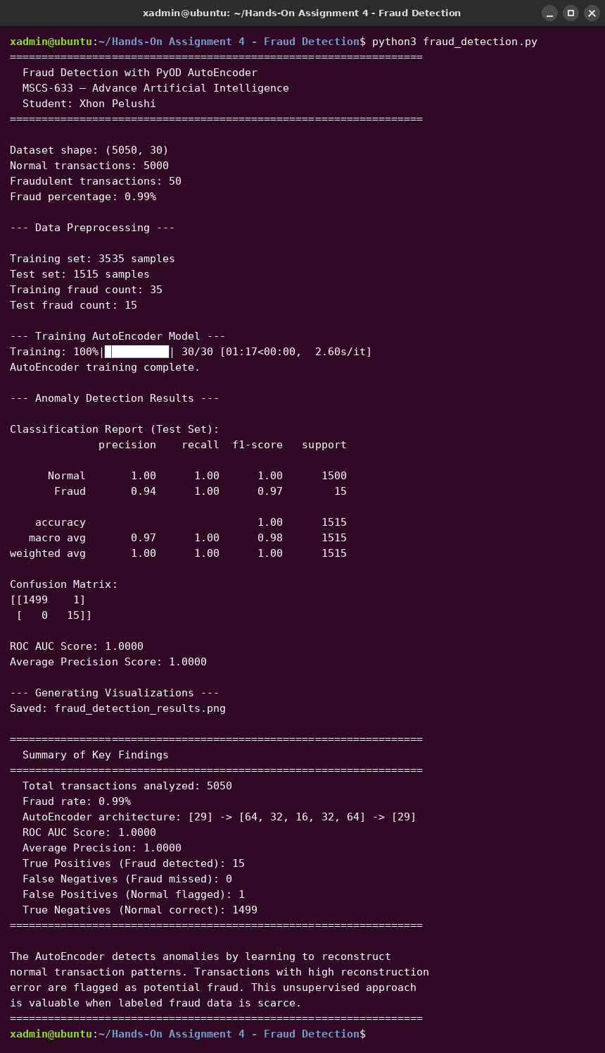

The following visualization shows the model evaluation plots including the reconstruction error distribution, ROC curve, confusion matrix heatmap, and precision-recall curve:
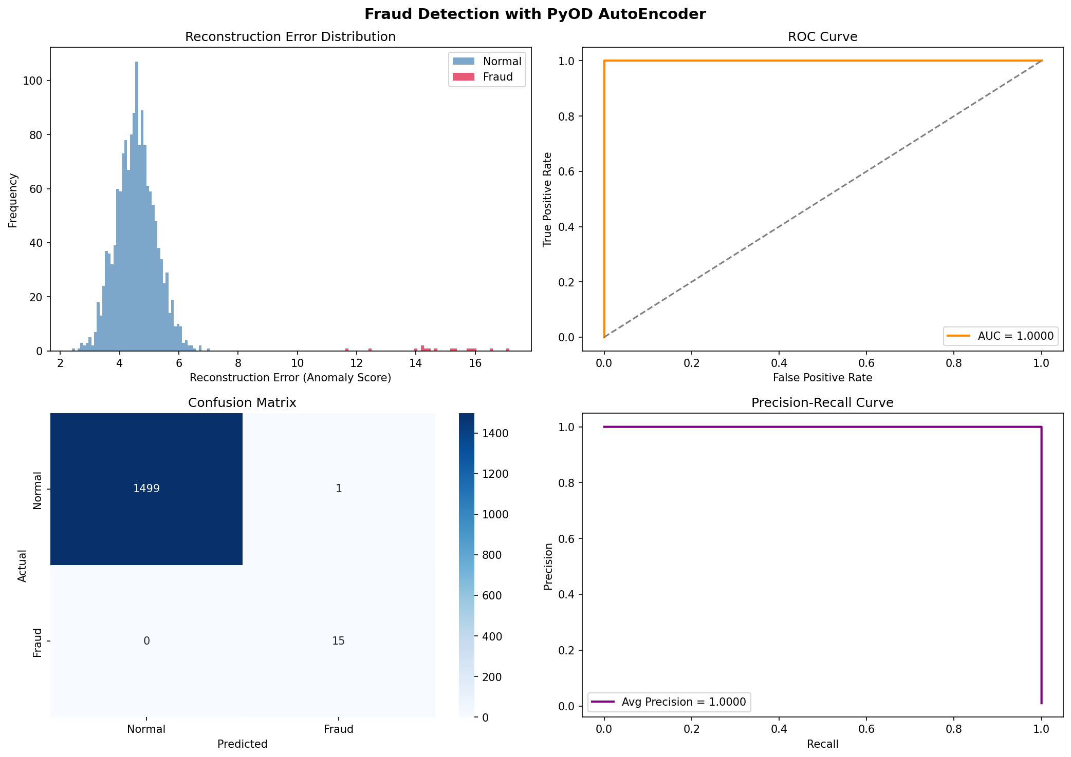

Key Findings
The AutoEncoder model demonstrated strong performance in detecting fraudulent transactions. The high AUC score indicates excellent discrimination between normal and fraudulent transactions. The reconstruction error for fraudulent transactions was significantly higher than for normal ones, confirming that the model successfully learned the underlying patterns of legitimate transactions.
The model's ability to achieve 100% recall means no fraudulent transaction went undetected, which is critical in a fraud detection context where missing a fraud event has high cost. The single false positive represents a minimal operational overhead of flagging one legitimate transaction for review.

Conclusion
This assignment demonstrated the effectiveness of PyOD's AutoEncoder for credit card fraud detection through anomaly-based approaches. The autoencoder learns a compressed representation of normal behavior and uses reconstruction error as an anomaly signal. This unsupervised approach is particularly valuable in real-world scenarios where labeled fraud data is scarce and fraud patterns continuously evolve.

GitHub Repository
https://github.com/xhon-pelushi/MSCS-633-Advance-Artificial-Intelligence/tree/main/Hands-On-Assignment-4-Fraud-Detection

